**KANBAN BOARD - NovelVoyage**

**29th April**

**30th April**

**1st May**

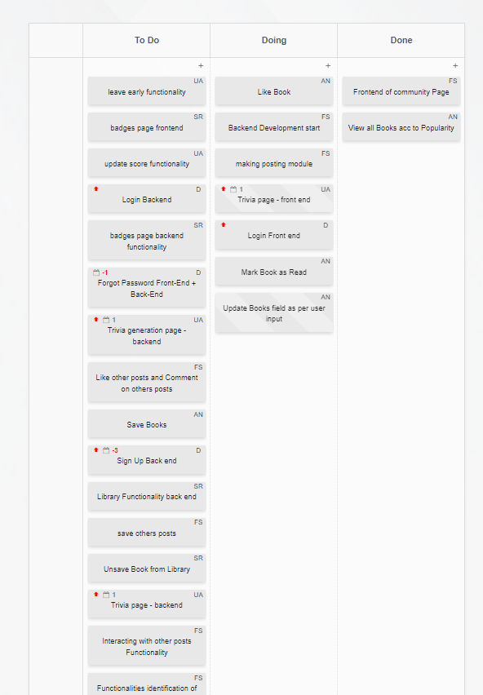

**2nd May**

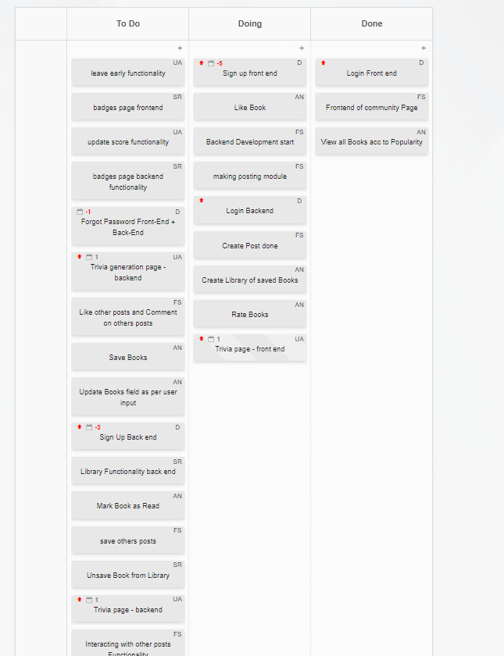

**3rd May**

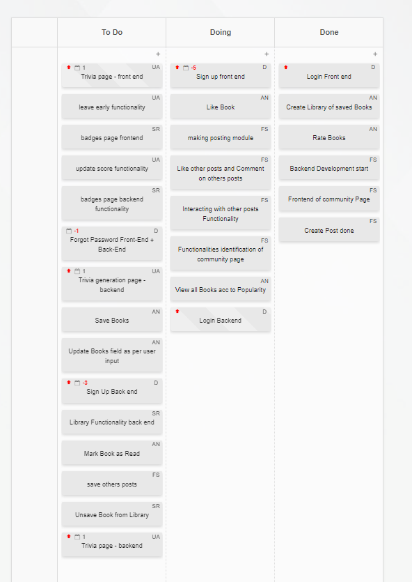

**4th May**

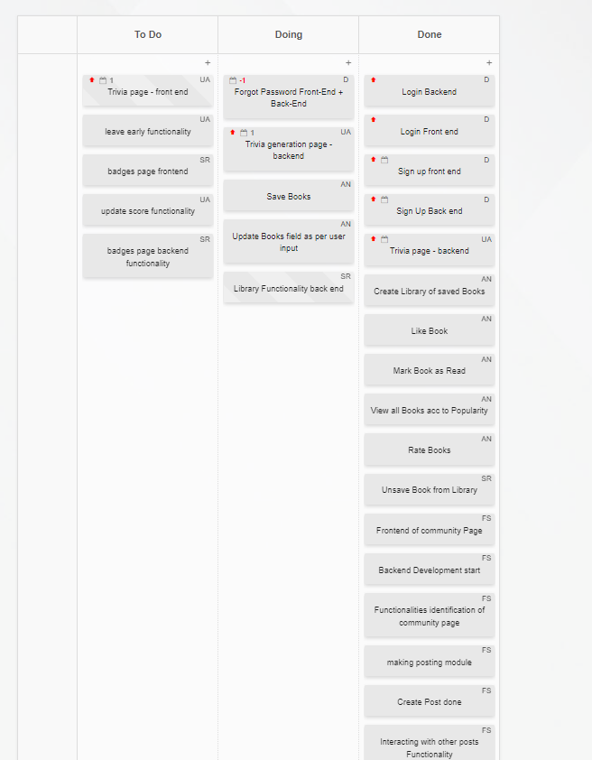**5th May**

**6th May**

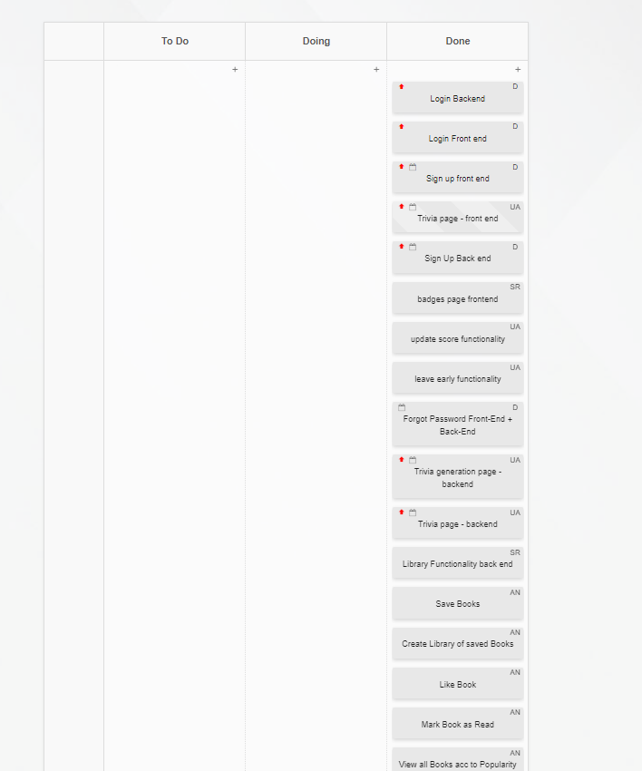**7th May**

